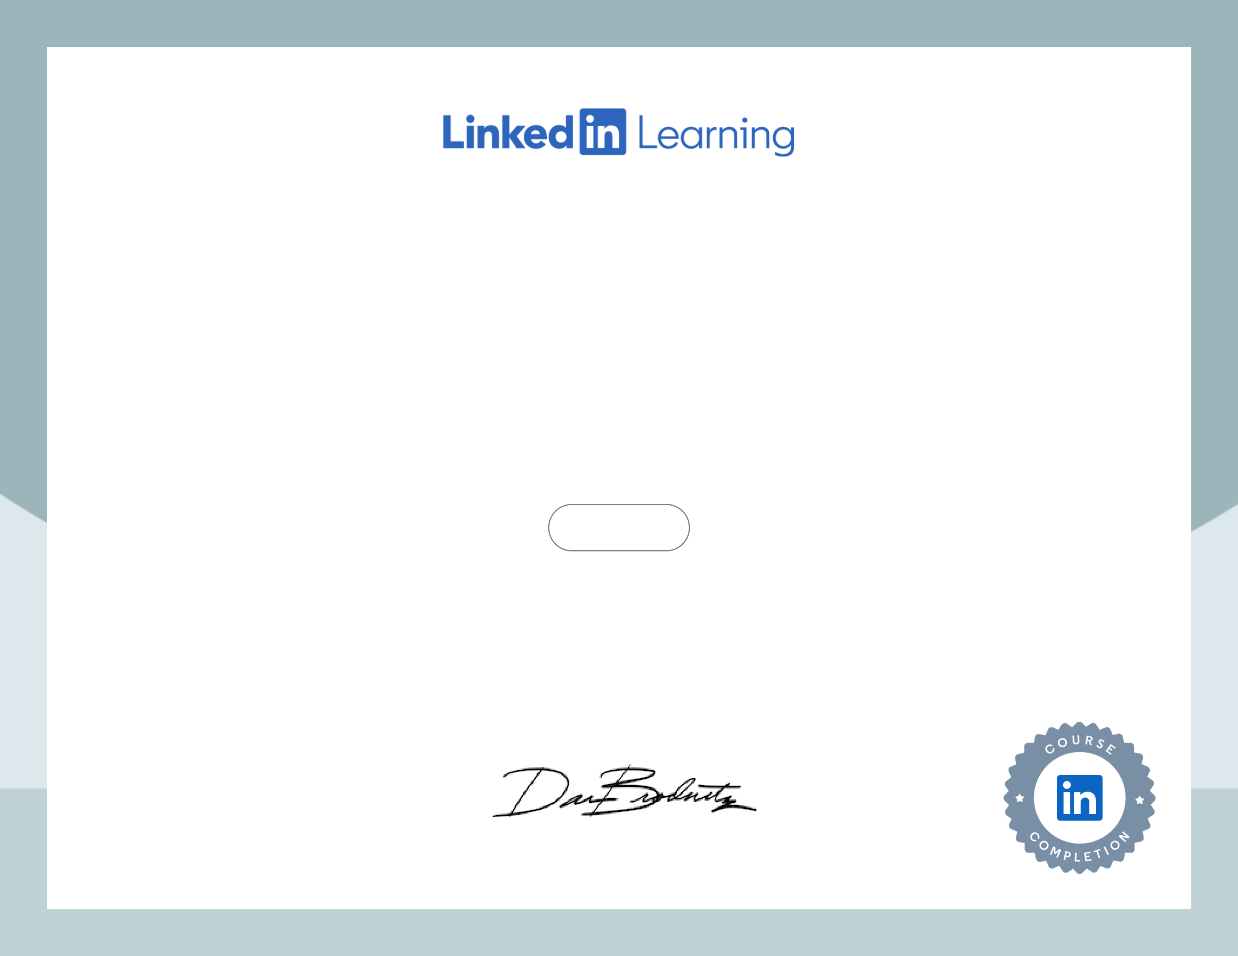

Negotiation Skills   
Course completed by Pawandeep Thandi   
Nov 18, 2024 at 05:41PM UTC 2 hours 7 minutes Top skills covered   
Negotiation

Head of Global Content, Learning

Certificate ID: c8b2a4c85c3bb847554451ace9b7235739a5d3668fc5b8e5942dc524f35e7655